Lab homework for week 2

cl_stnt - character

stnt_year - numeric

stnt_score - numeric

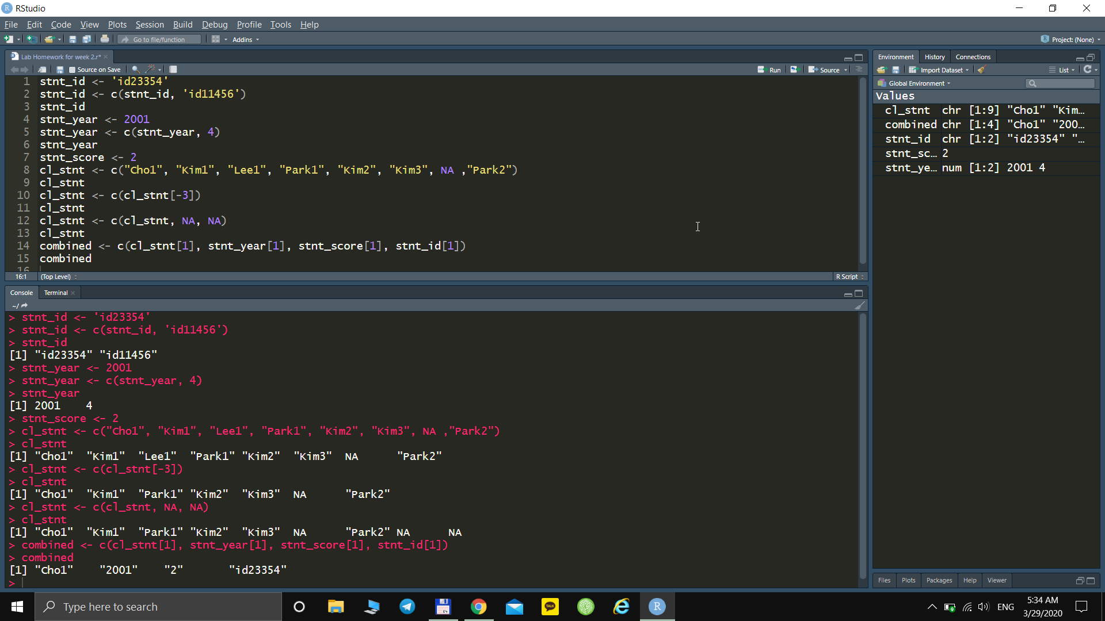

According the result combined data should be a character.

Here is a proof

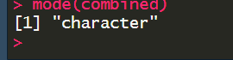

That’s all, thank you.